**Perception Design Document**

A game based on using what you perceive to overcome challenges.

Team Members:

Stephen MacDonald (Scrum Master)

Zach Curll

Laura Amoroso

Zack Reynolds

Github: https://github.com/Perception-Game/main

Slack: <https://perceptiongame.slack.com/>

**Project Design:**

This is a project based around creating a puzzle game using the Unity engine in order to create a visual based 3D environment puzzle game. The main component for problem solving will be the player’s ability to pick up objects that are not to scale. These then, smaller or larger objects can be used to solve puzzles.

The architecture of this project is to have several completed Unity scenes that will link together to form the entire game. These will be divided up into the following levels:

**Level 1: Forest**

Worked on by everyone.

Player spawns in forest with lion statue and locked door. Play must take sun from sky and place it within a reasonable range of the lion statue. This will trigger the door to open. The player will then go through the door to go to the next level.

**Level 2: Mountain**

To be made by Stephen MacDonald.

Player spawns atop rigid mountain range. There will be several steep crevasses between mountain tops. The player will need to obtain a hidden axe saw to cut down a tree. Then use power to use the log as a bridge. After crossing the bridge, the player will have to hop across platforms until they reach a series of rotating block cylinders. The cylinders launch the player to different platforms until they reach a button to open a door to a mountain shaped keyhole. The player will then encounter a puzzle involving reaching out into the mountaintops in the distance and finding one of the background mountains to actually be grabable, and used in the opening of a door to lead to the end of the puzzle. In the end, the player will find a cave entrance that should lead to next level.

**Level 3: Cave**

To be made by Zach Curll.

Within the dark cave, the player will be forced through a long maze of tunnels while only having limited lighting. The player will come across rocks blocking their path and unpassable and deadly lava. The player will have to rescale rocks to access the next part of the cave and will also have to rescale rocks to get across unpassable lava. The player will also have to bring a bucket of water to a lion statue to remove lava that is blocking their path. Once the player brings the water to the statue the lava will be removed from the room and rocks will appear to allow them to jump up to the next part of the cave. Once the player jumps up the rocks and reaches the next part of the cave they will have to jump on rocks to avoid deadly lava that is below them in order to reach the exit. Once the player reaches the exit the player will leave the cave and enter the desert.

**Level 4: Desert**

To be made by Laura Amoroso.

The player will be confronted by three lion statues that are red, blue, and yellow. It should be understood that the player should search the desert for one item of each color. For example, the red statue would require a red object. A red object in the middle of the desert could be a red cactus flower. Additionally, each color item should require a tiny puzzle to obtain each. For example, a seesaw mechanic will be used to get up high to obtain an object. Another object may be hidden in a maze that requires the user to scale down objects to get past them. Once all three objects are given to their respective lion statue, a gate and hallway leading to the castle level will then open.

**Level 5: Castle**

To be made by Zach Reynolds.

The player spawns in a cell. Once the player puts the coins in the bucket to open the gate, the player will go through a maze. Within that maze will be locked doors and hidden keys to open them. Similar mechanics and puzzles used in the previous levels will all be used. Then the player will go to the forge and have to melt a sword to get a key and to open the next door. In the next room, the player will have to put a barrel in a crate to make stairs appear, and get the first dragon statue and give a rock to the lion to get the second stairs. Then the player will need to get the torch and go up the second stairs and burn down the barrels to press the button to open the door. In the last room the player will need to place two dragon statues on the pedestals to open the final door to end the game.

Additionally, there will be a start screen with a menu. The menu may contain several buttons. One to start the game, another for options, and one for the credits.

**Problem solving approaches:**

* Work delegation: In order to create a fairly distributed work, we decided to each work on our respective scenes and levels that will be put together later on in the project’s timeline.
* Unity version to use. Due to not all group members having access to Unity 2017.2.03f, some group members may use a newer version in their git branch. In the end, we will merge all the branches and we may update the entire game to a newer version of unity.
* The slow startup of using Unity. We plan to use personal storage devices to load the software faster.

**Game Mockups:**

**Desert Level:**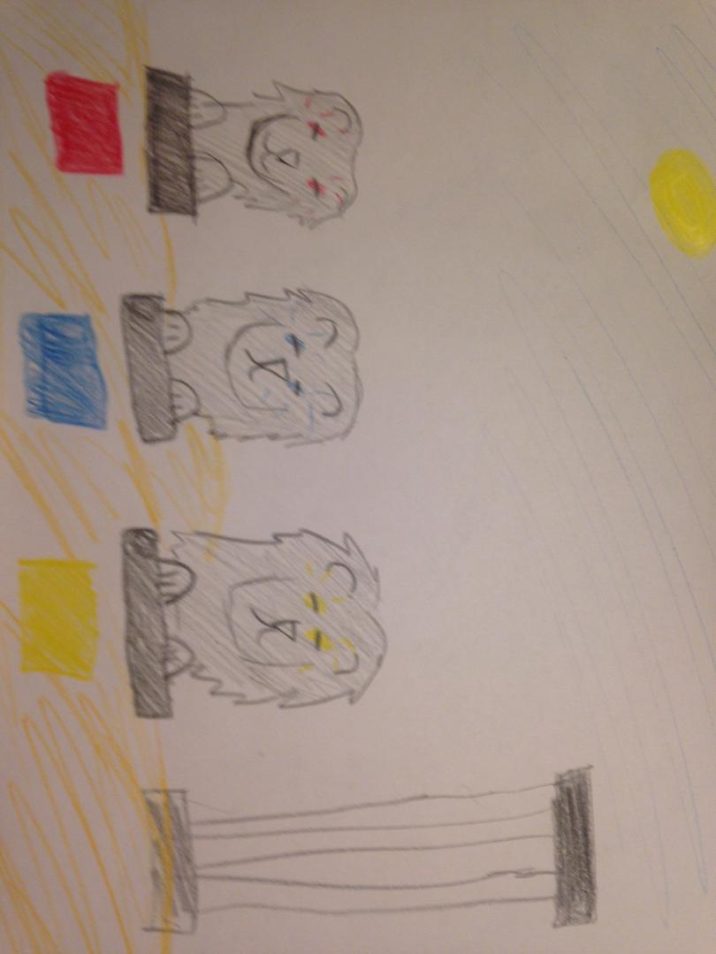

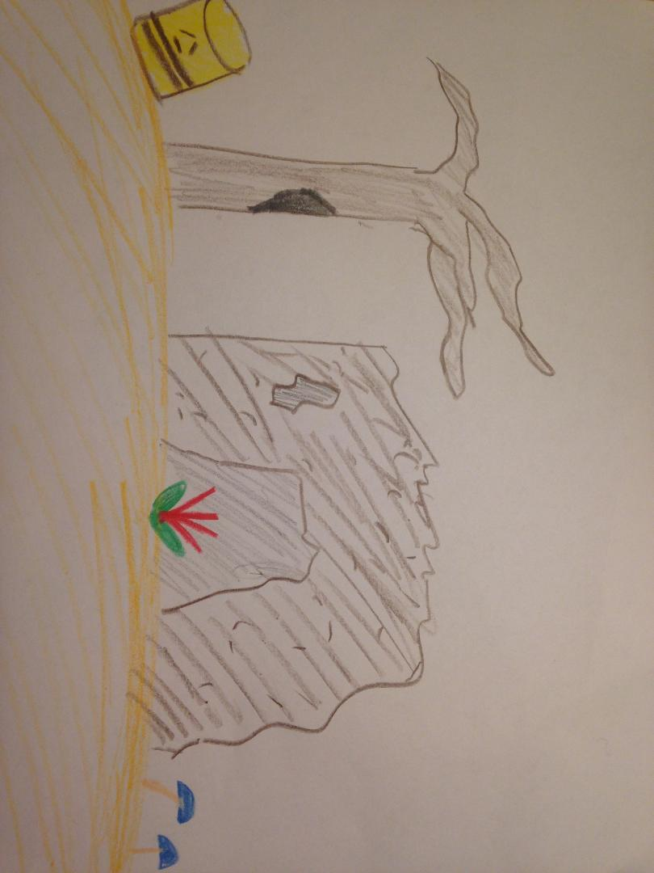

**Mountain Level:**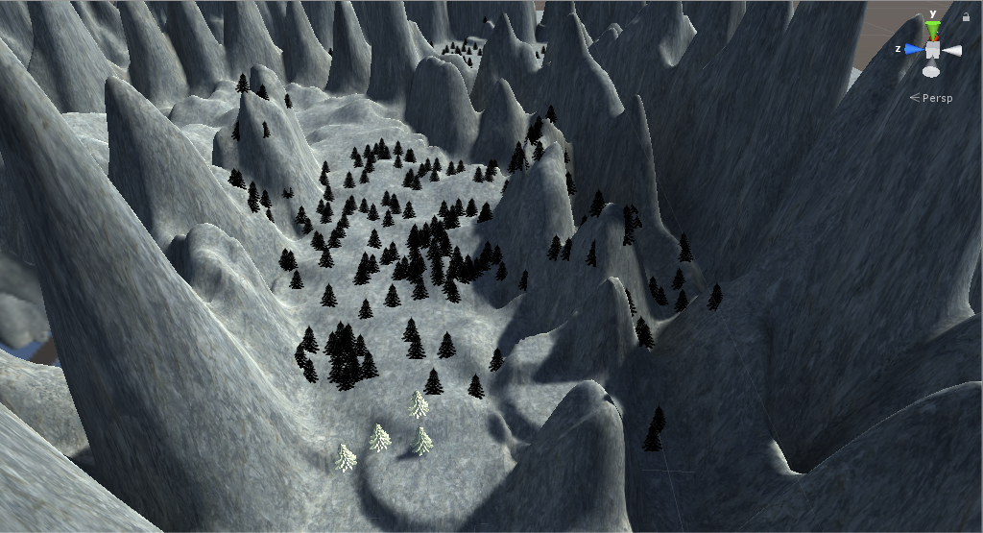

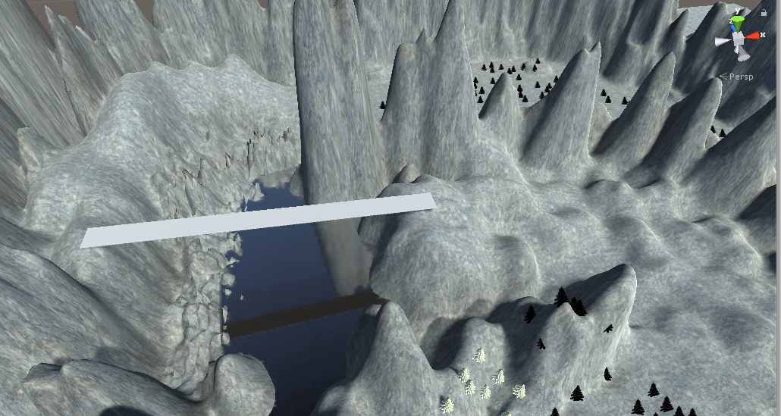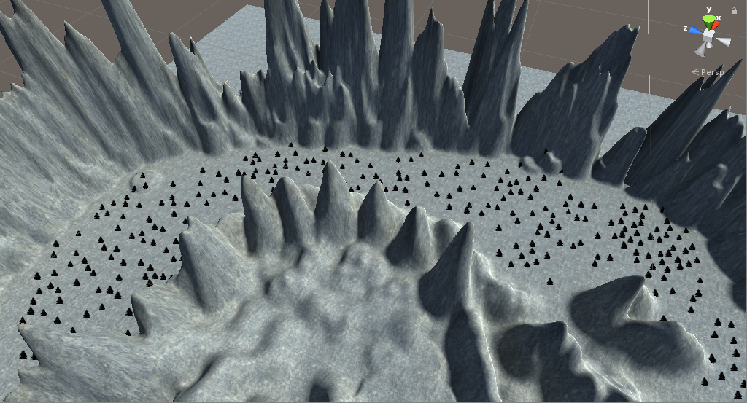

**Castle Level:**

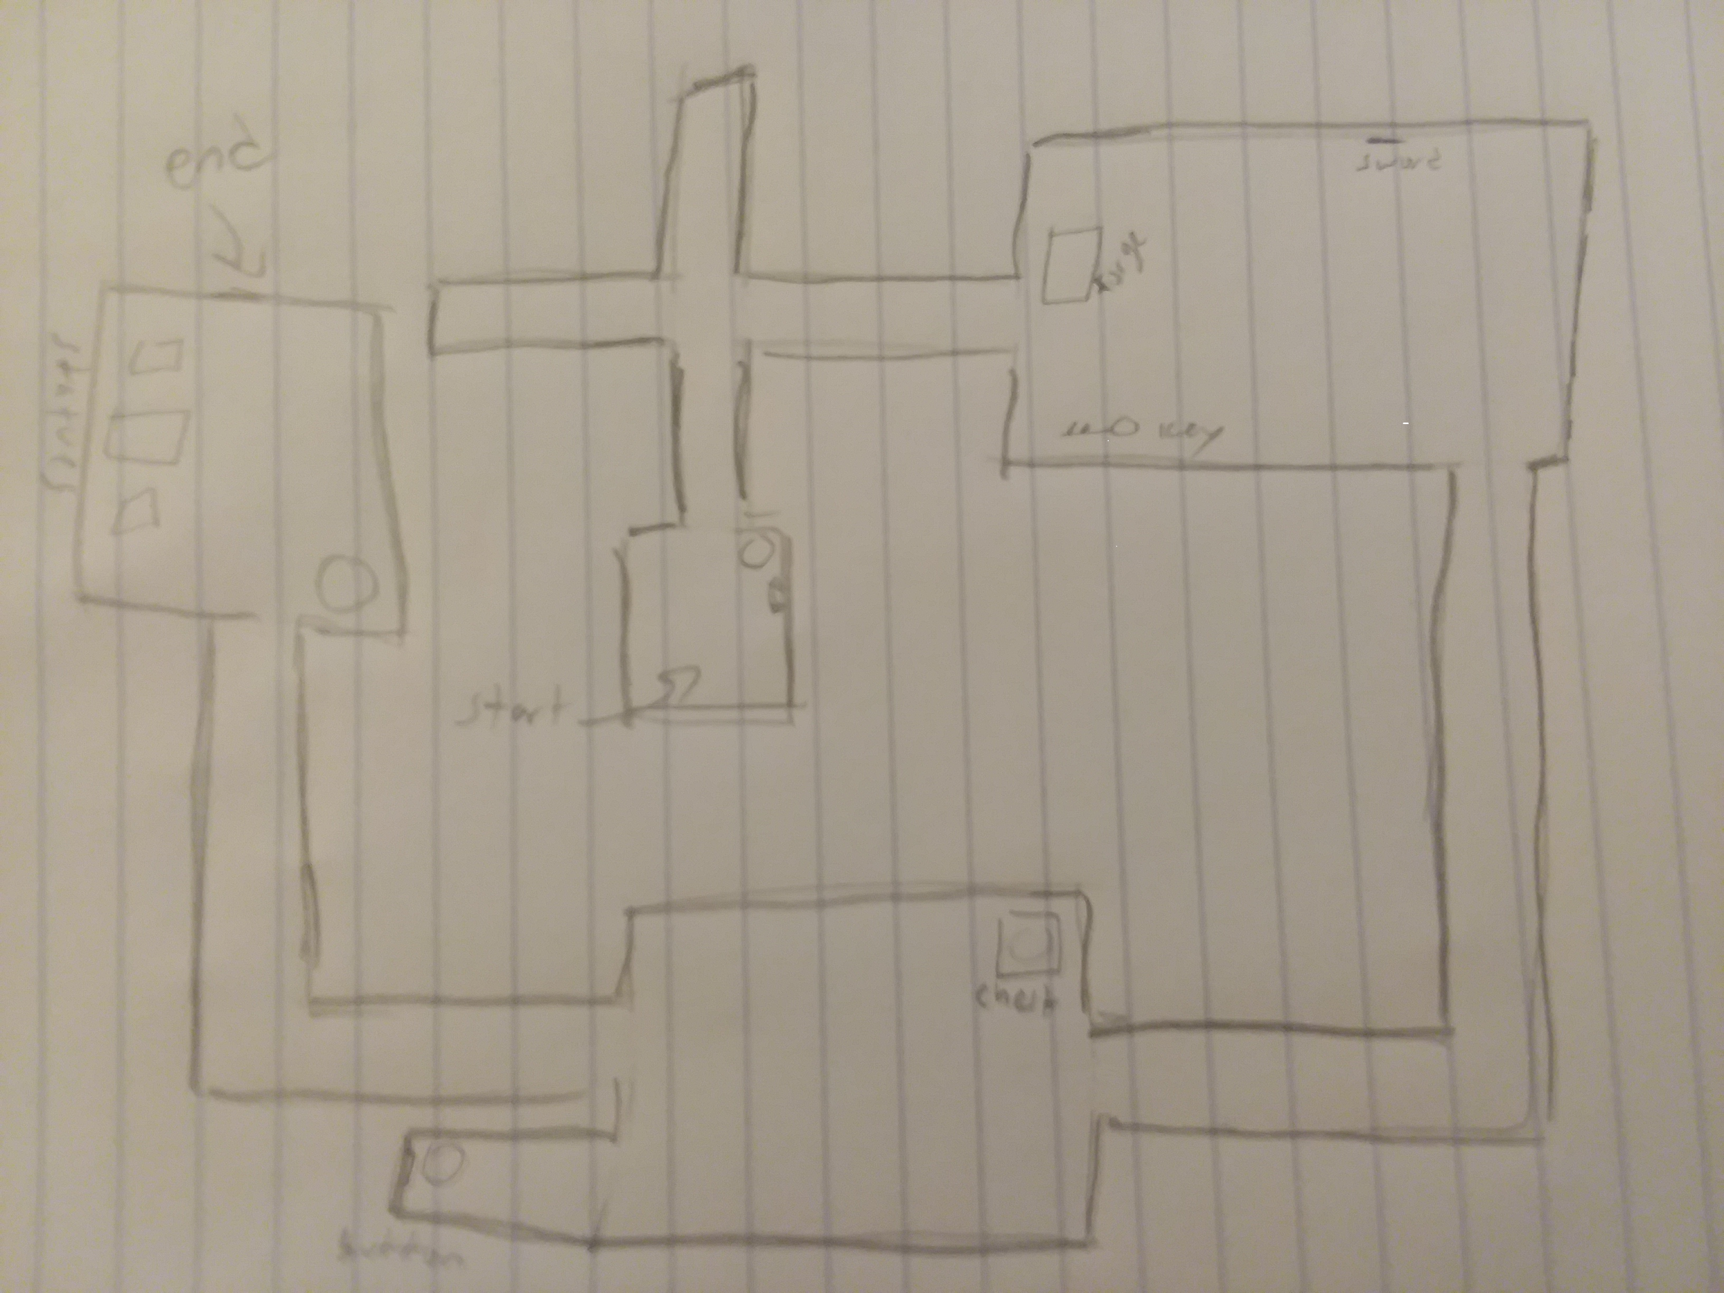

**---------------------------------------------------------------------------------------------------------------------**

**Cave Level:**

* **OverView:**

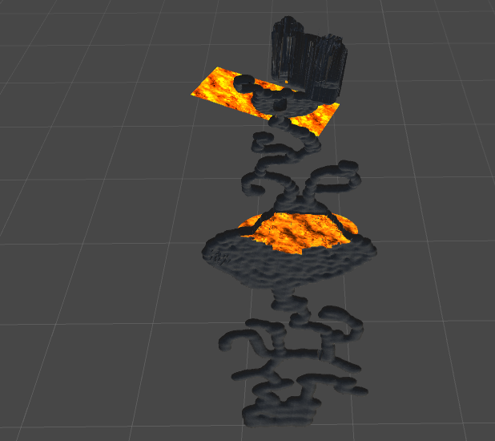

* **Start/PlayerView:**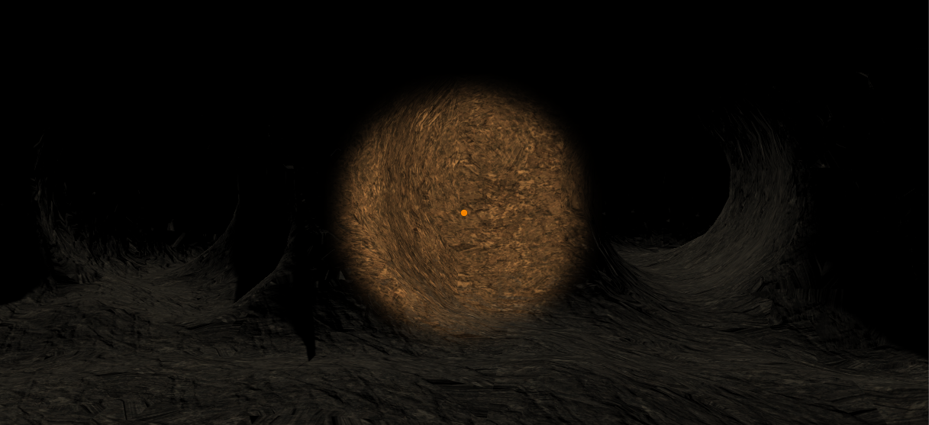
* **Lava:**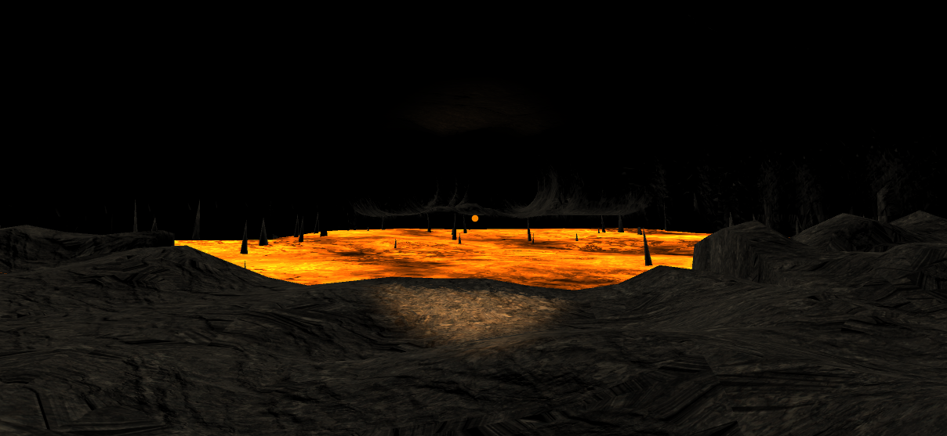
* **Rocks:**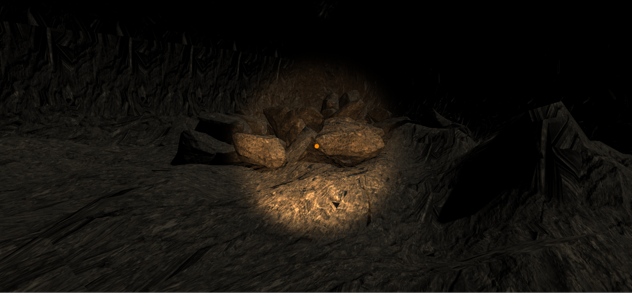
* **Cave In:**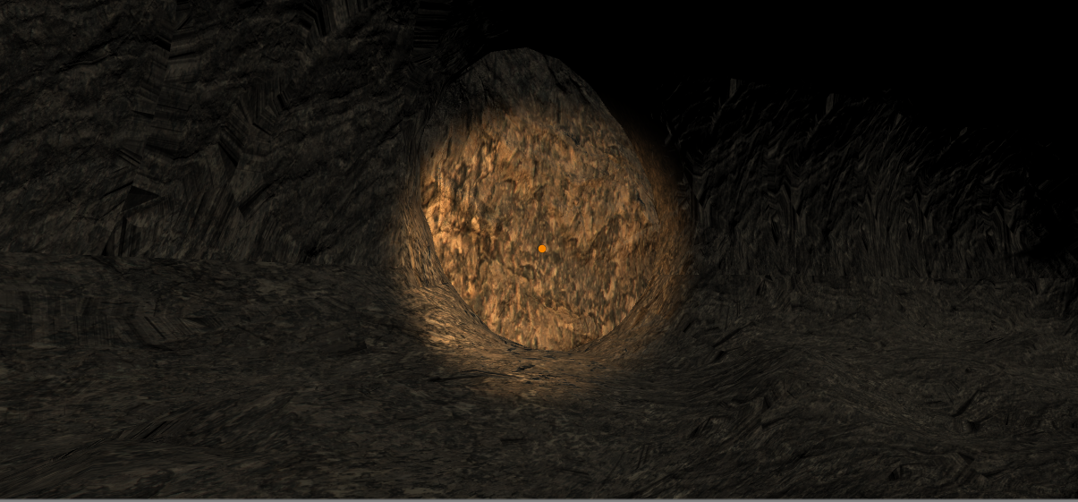
* **Lava Orb:**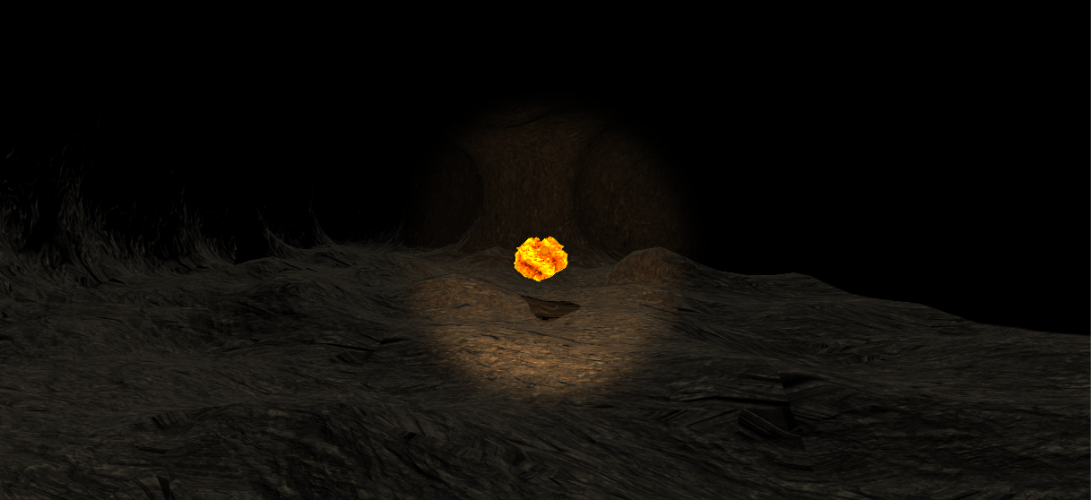
* **Lion Statue:**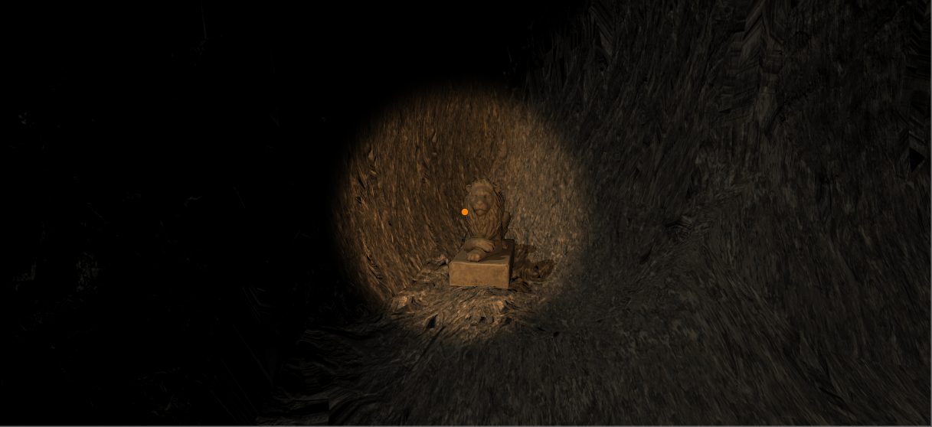

**---------------------------------------------------------------------------------------------------------------------**

Development platforms:

* Github
* Unity 2017.2.03f
* MonoDevelop
* Microsoft Visual Studio 2017

Languages Used:

* C#

Mid-assessment Goals:

**Laura Amoroso**: High quality sound effects and background music.

**Stephen MacDonald**: Finalizing level and getting bugs fixed. Also perfecting grab functionality and adding glow functionality to grabbable items when looking at them.

**Zach Reynolds**: Get the levels working together.

**Zach Curll**: Finish current level by making it look better and have better functionality.

As a group we will also accomplish the following:

* Multiple levels that function independently and link together
* 3 to 4 movable objects per level
* Great detail in each level and a lot of background sound
* Common assets in each level to provide a sense of unity.